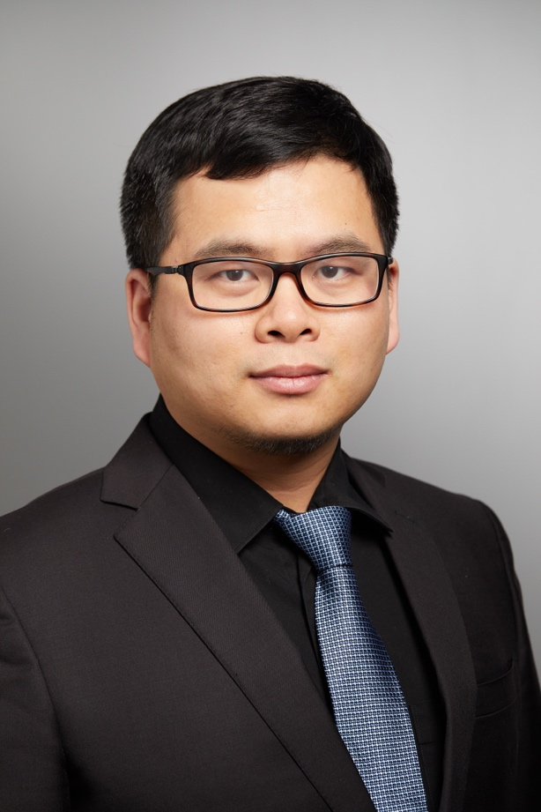

Bio:
Yansheng Liu is an Associate Professor in the Department of Pharmacology at Yale University School of Medicine. He is also a group leader in proteomics at Yale Cancer Biology Institute. Dr. Liu received his Ph.D. from the Chinese Academy of Sciences in 2011. He then carried out his post-doctoral training at ETH Zurich, Switzerland. In December 2017, Dr. Liu joined the faculty at Yale. His research program is focused on analyzing protein turnover and post-translational modifications for understanding cancer aneuploidy, cellular signaling transduction, and biodiversity. The Liu Lab also aims to develop DIA-MS approaches. Dr. Liu has received 2021 ASMS Research Award, HUPO ECR Award, and 2023 US HUPO Robert J. Cotter Award. He serves as an editorial board member of Proteomics and a member of the HUPO Awards Committee and HUPO ETC Committee.

